**HTML** project about

**Computer Architecture**

**Name :** Muhammad Usama Aowad Aowad

B.N. : 660

# Computer Architecture

In computer engineering, computer architecture is a set of rules and methods that describe the functionality, organization, and implementation of computer systems.

Some definitions of architecture define it as describing the capabilities and programming model of a computer but not a particular implementation. In other definitions computer architecture involves instruction set architecture design, microarchitecture design, logic design, and implementation.

**Computer**

Computer is a programmable, electronic device that accepts data, performs operations, presents the results, and can store the data.

**Some definitions you should know :**

* **Input :** data into the computer.
* **Output :** Presenting the results.
* **Processing :** Performing operations on the data.
* **Storage :** Saving data, programs, or output for future use.

------------------------------------------------------------------------------------------------------------------------

# Input Devices

An input device is a piece of equipment used to provide data and control signals to an information processing system such as a computer or information appliance.

**Examples of input devices :**

* Keyboard
* Mouse and TouchPad
* Microphone
* Scanner

# Output Devices

An output device is any piece of computer hardware equipment which converts information into human readable form. It can be text, graphics, tactile, audio, and video. Some of the output devices are Visual Display Units (VDU) i.e. a Monitor, Printer graphic Output devices, Plotters, Speakers etc. A new type of Output device is being developed these days, known as Speech synthesizer, a mechanism attached to the computer which produces verbal output sounding almost like human speeches.

**Examples of output devices :**

* Monitor
* Printer
* Speaker
* Plotter

------------------------------------------------------------------------------------------------------------------------

# MotherBoard

A motherboard (also called mainboard, main circuit board, system board, baseboard, planar board, logic board, or mobo) is the main printed circuit board (PCB) in general-purpose computers and other expandable systems. It holds and allows communication between many of the crucial electronic components of a system, such as the central processing unit (CPU) and memory, and provides connectors for other peripherals. Unlike a backplane, a motherboard usually contains significant sub-systems, such as the central processor, the chipset's input/output and memory controllers, interface connectors, and other components integrated for general use.

Motherboard means specifically a PCB with expansion capabilities. As the name suggests, this board is often referred to as the "mother" of all components attached to it, which often include peripherals, interface cards, and daughtercards: sound cards, video cards, network cards, host bus adapters, TV tuner cards, IEEE 1394 cards; and a variety of other custom components.

Similarly, the term mainboard describes a device with a single board and no additional expansions or capability, such as controlling boards in laser printers, television sets, washing machines, mobile phones, and other embedded systems with limited expansion abilities.

It is on the size of A4 paper, its color is green or gold.

**The motherboard consists of components, we can mention them in the following list :**

* Disk controllers for SATA drives, and historical PATA drives.
* Historical floppy-disk controller.
* RAM slots.
* Processor (CPU), on which a fan or a heat sink is mounted.
* Power supply to convert the 200V ac to 3.3V.
* Expansion slots.
* Ethernet network controller for connection to a LAN and to receive Internet.
* USB controllers.
* Clock, which generates series of pulses per second.
* Battery.

------------------------------------------------------------------------------------------------------------------------

# CPU

A central processing unit (CPU), also called a central processor, main processor or just processor, is the electronic circuitry that executes instructions comprising a computer program. The CPU performs basic arithmetic, logic, controlling, and input/output (I/O) operations specified by the instructions in the program. This contrasts with external components such as main memory and I/O circuitry, and specialized processors such as graphics processing units (GPUs).

The form, design, and implementation of CPUs have changed over time, but their fundamental operation remains almost unchanged. Principal components of a CPU include the arithmetic logic unit (ALU) that performs arithmetic and logic operations, processor registers that supply operands to the ALU and store the results of ALU operations, and a control unit that orchestrates the fetching (from memory) and execution of instructions by directing the coordinated operations of the ALU, registers and other components.

Most modern CPUs are implemented on integrated circuit (IC) microprocessors, with one or more CPUs on a single metal-oxide-semiconductor (MOS) IC chip. Microprocessors chips with multiple CPUs are multi-core processors. The individual physical CPUs, processor cores, can also be multithreaded to create additional virtual or logical CPUs.

An IC that contains a CPU may also contain memory, peripheral interfaces, and other components of a computer; such integrated devices are variously called microcontrollers or systems on a chip (SoC).

Array processors or vector processors have multiple processors that operate in parallel, with no unit considered central. Virtual CPUs are an abstraction of dynamical aggregated computational resources.

------------------------------------------------------------------------------------------------------------------------

# Machine Cycle

**Machine cycle :** the amount of time needed to execute an instruction.  
Personal computers execute in less than one millionth of a second.  
Supercomputers execute in less than one trillionth of a second.  
Each CPU has its own instruction set.

------------------------------------------------------------------------------------------------------------------------

# Memory

Memory is a device or system that is used to store information for immediate use in a computer or related computer hardware and digital electronic devices. The term memory is often synonymous with the term primary storage or main memory. An archaic synonym for memory is store.

Computer memory operates at a high speed compared to storage that is slower but offers higher capacities. If needed, contents of the computer memory can be transferred to storage; a common way of doing this is through a memory management technique called virtual memory.

Modern memory is implemented as semiconductor memory, where data is stored within memory cells built from MOS transistors on an integrated circuit. There are two main kinds of semiconductor memory, volatile and non-volatile. Examples of non-volatile memory are flash memory and ROM, PROM, EPROM and EEPROM memory. Examples of volatile memory are primary storage, which is typically dynamic random-access memory (DRAM), and fast CPU cache memory, which is typically static random-access memory (SRAM) that is fast but energy-consuming, offering lower memory areal density than DRAM.

Most semiconductor memory is organized into memory cells or bistable flip-flops, each storing one bit (0 or 1). Flash memory organization includes both one bit per memory cell and multi-level cell capable of storing multiple bits per cell. The memory cells are grouped into words of fixed word length, for example, 1, 2, 4, 8, 16, 32, 64 or 128 bits. Each word can be accessed by a binary address of N bits, making it possible to store 2N words in the memory.

# Storage

# Computer data storage is a technology consisting of computer components and recording media that are used to retain digital data. It is a core function and fundamental component of computers. Storage, also known as mass media or auxiliary storage, refers to the various media on which a computer system can store data. Storage devices hold programs and data in units called files, files are stored in directories or folders.

**Why is storage necessary ?**

**Storage :**

* Retains data when the computer is turned off.
* Is cheaper than memory.
* Plays an important role during startup.
* Plays an input role when starting applications.
* Is needed for output.
* Devices can hold a large amount of data.

**Types of storage technologies :**

* **Sequential :**Hardware that reads and writes data in a serial (one after the other) fashion.
* **Random Access :** Hardware that reads and writes data without going through a sequence of locations.
* **Magnetic :** Hardware that uses disks or tapes that are coated with magnetic material.
* **Optical :** Hardware that uses laser beams to read data from plastic disks.
* **Solid State :** Devices that use nonvolatile memory chips to read and write data.

## The storage hierarchy

**Storage hierarchy consists of three levels :**

* **Online storage :**  Also called primary storage, it is made up of the storage devices that are actively available to the computer system. User action is not required.
* **Near online storage :** Also called secondary storage, it is not readily available to the computer system. The user performs an action, such as inserting a disk, to make it available.
* **Offline storage :** Also called tertiary storage or archival storage, it is not readily available to the computer system. Devices such as tape backup units store data for archival purposes.

**Storage Devices**

**Examples of storage devices :**

* Floppy disk
* CD-ROM
* DVD
* Hard disk

**Screenshots**

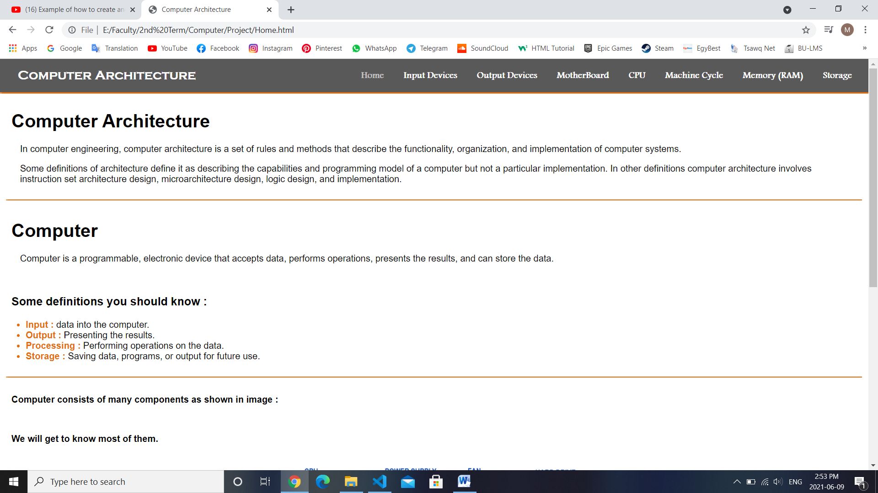

**Part of home page :**

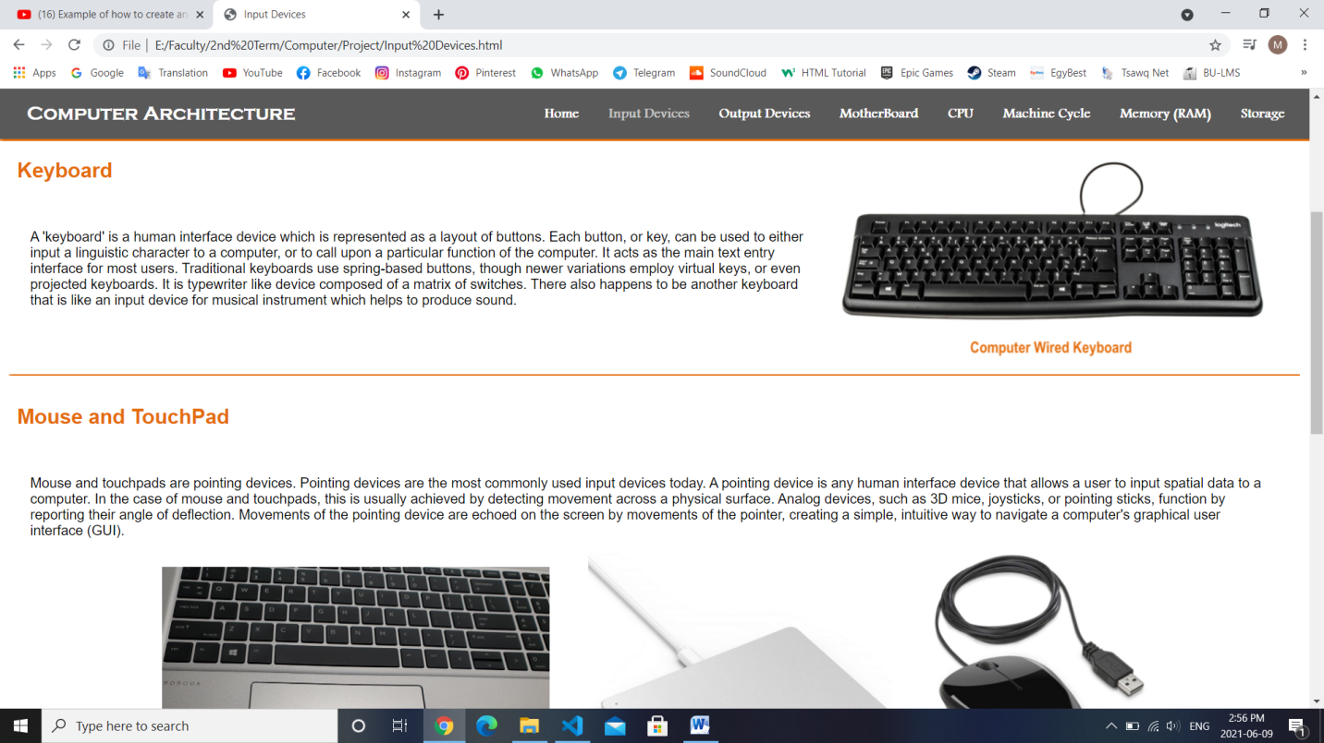**Part of input devices page :**

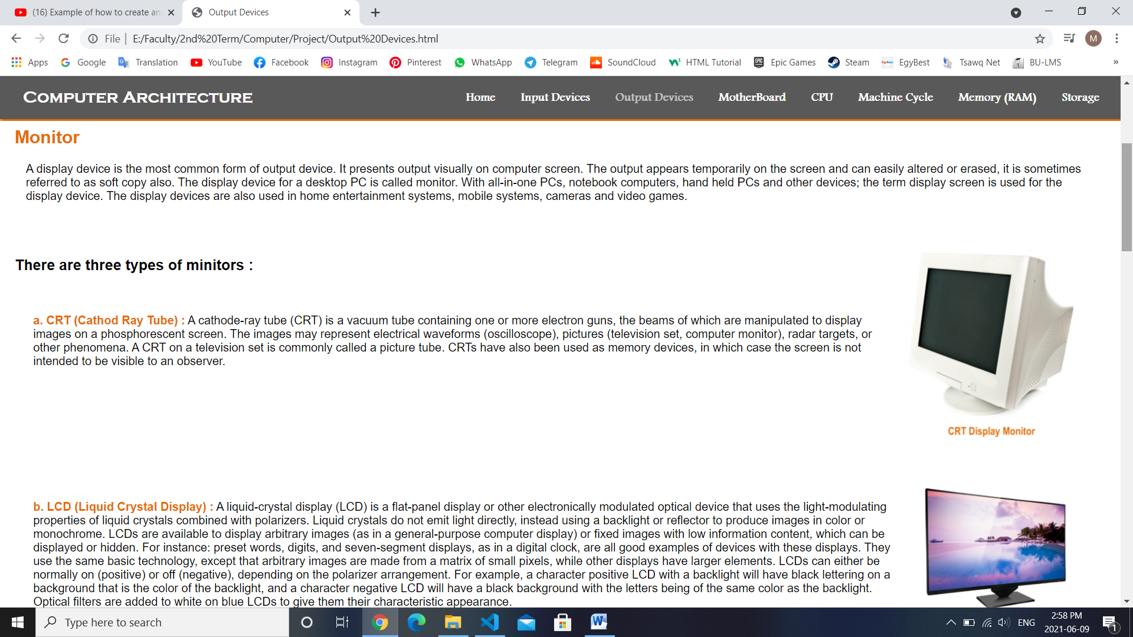**Part of output devices page :**

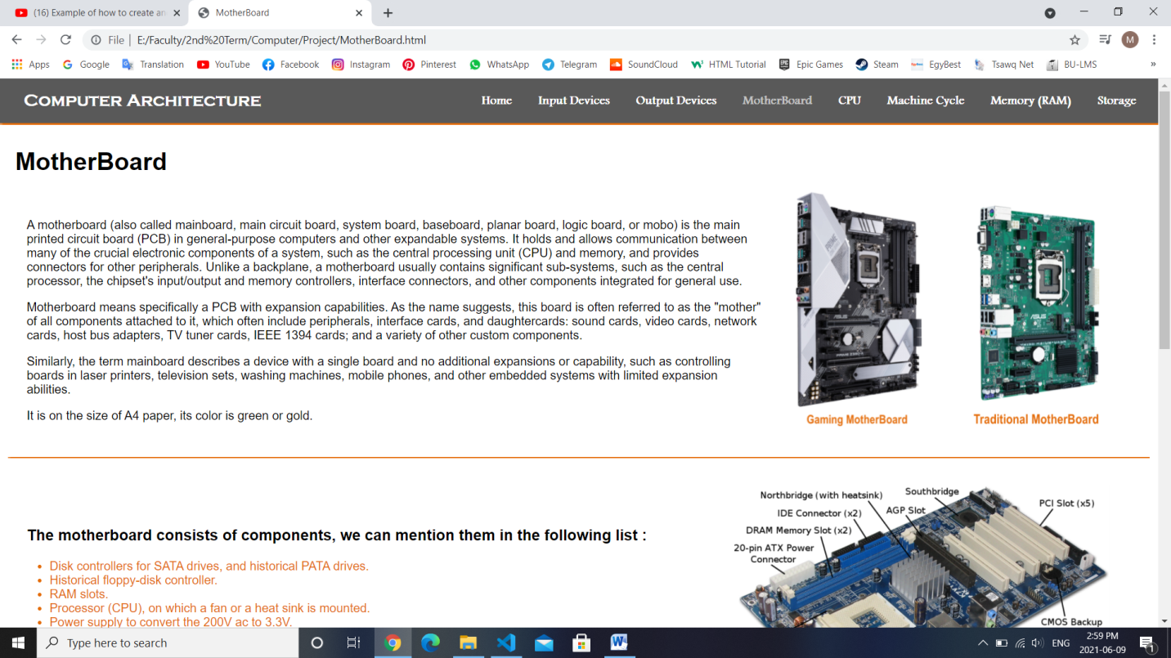**Part of motherboard page :**

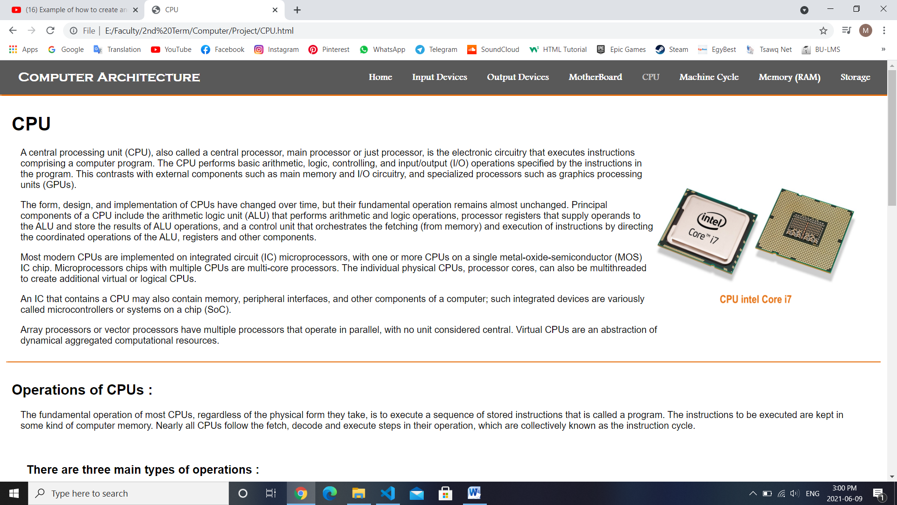**Part of CPU page :**

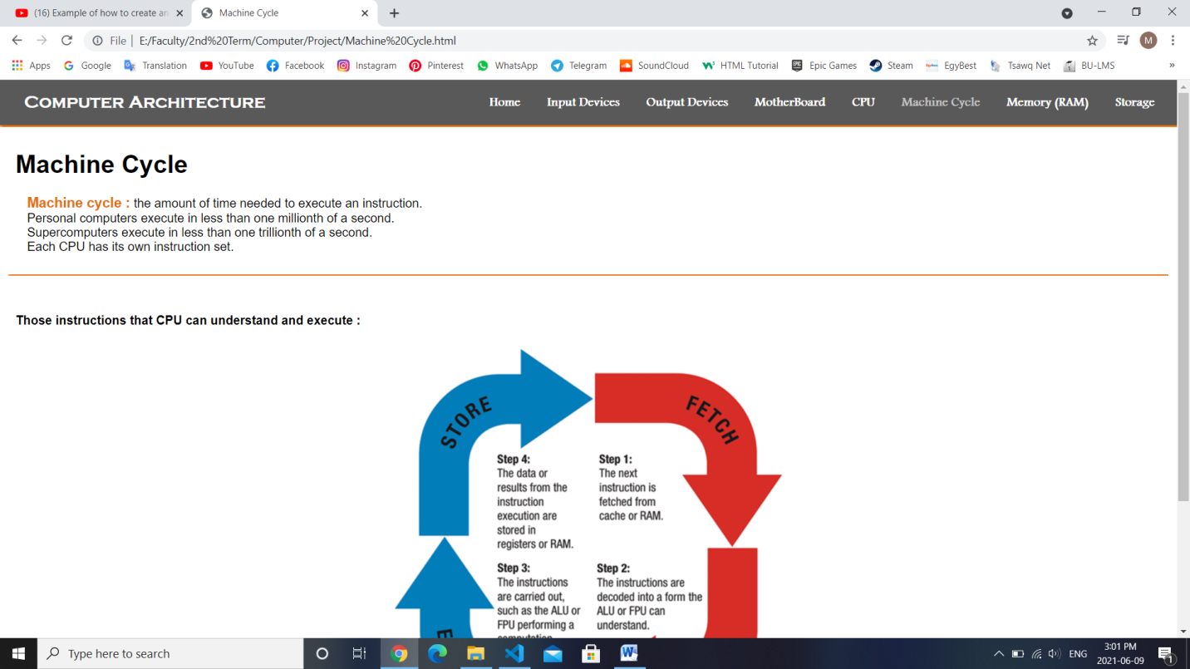

**Part of machine cycle page :**

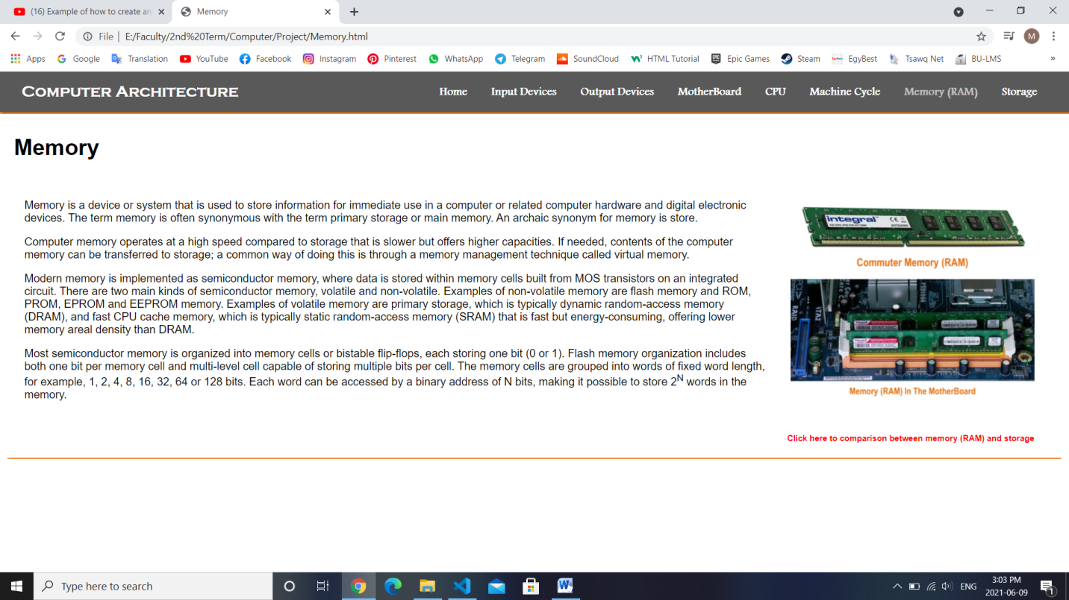**Memory (RAM) page :**

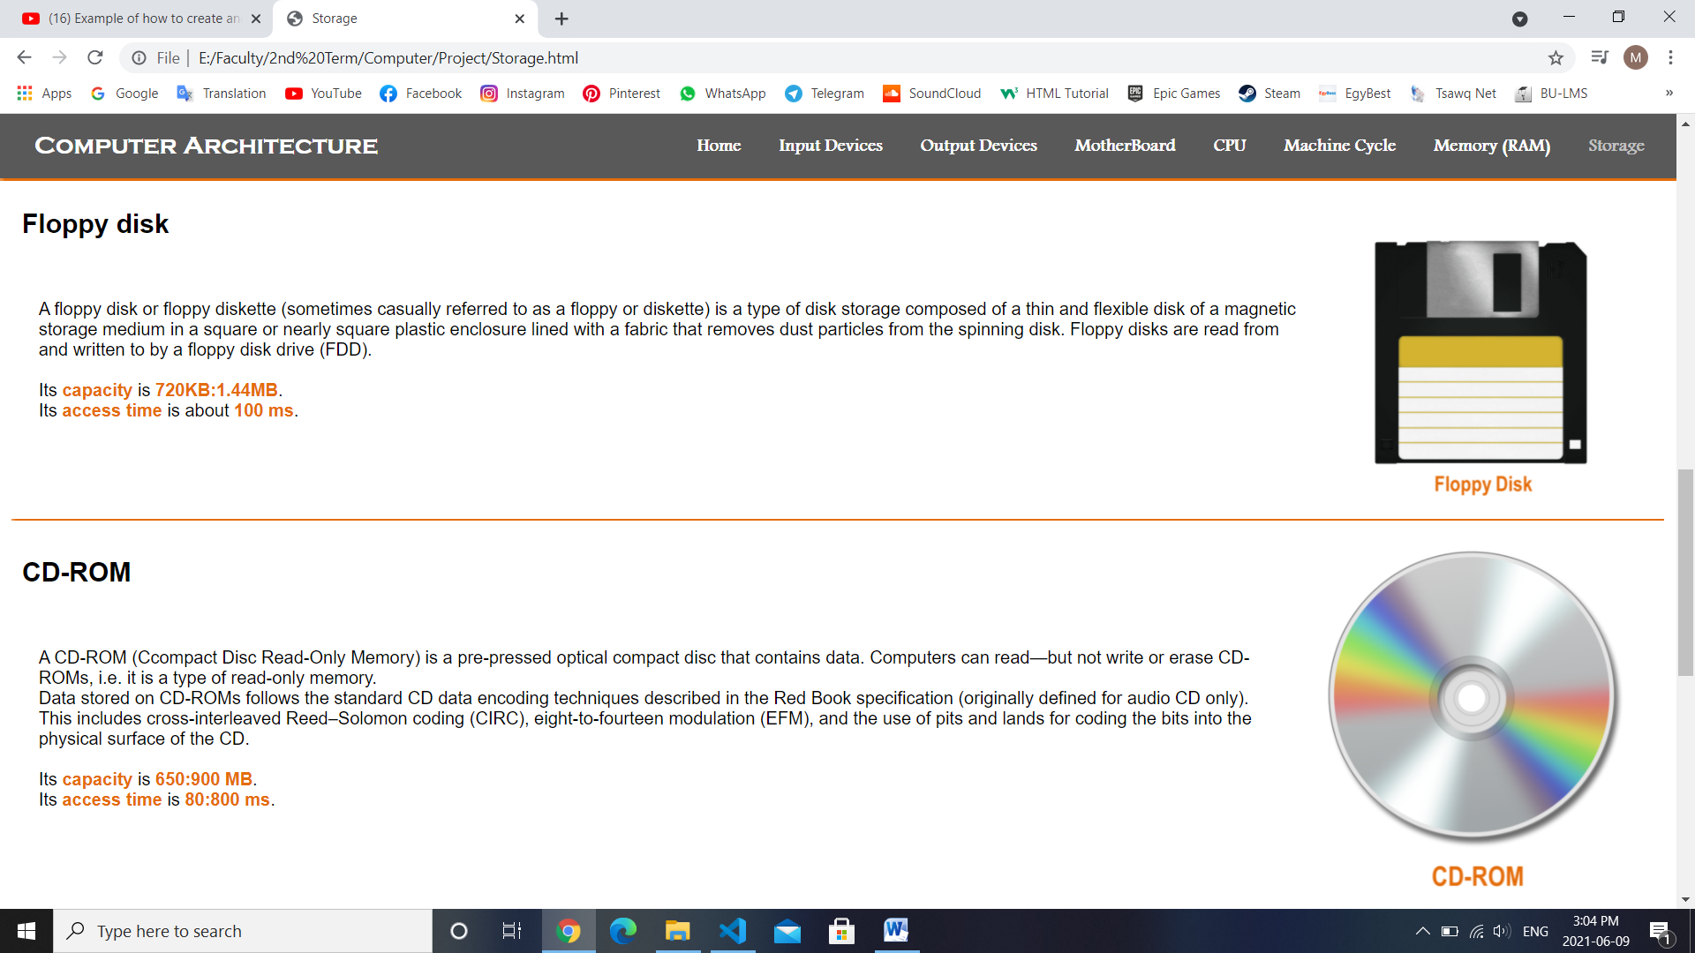**Part of storage page :**

**Memory VS. storage page :**

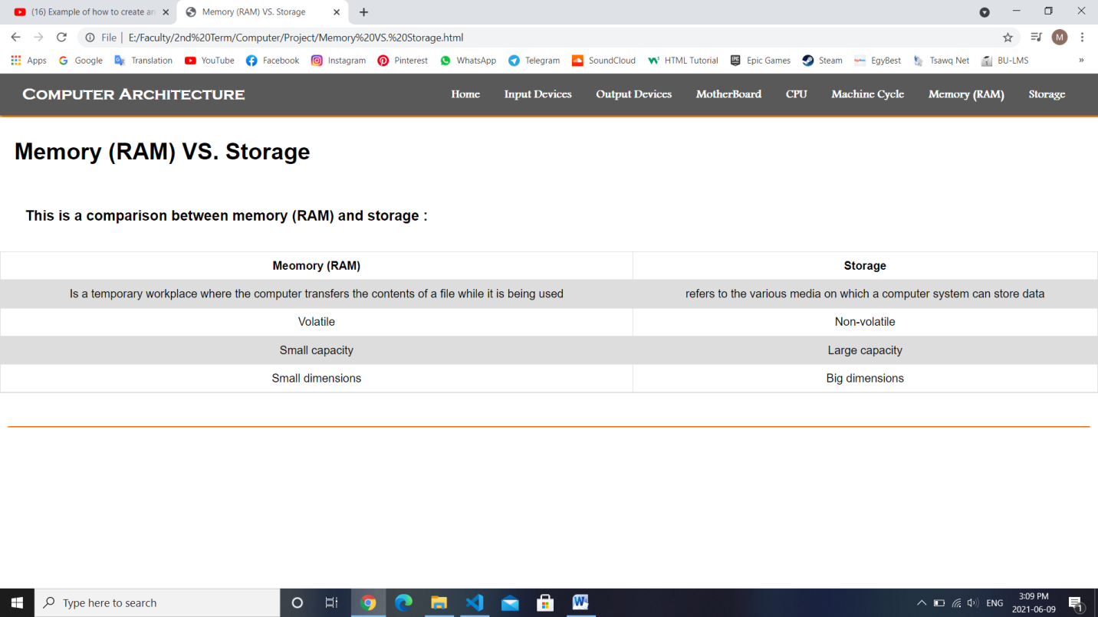

**Source codes :**

**Part of home page code :**

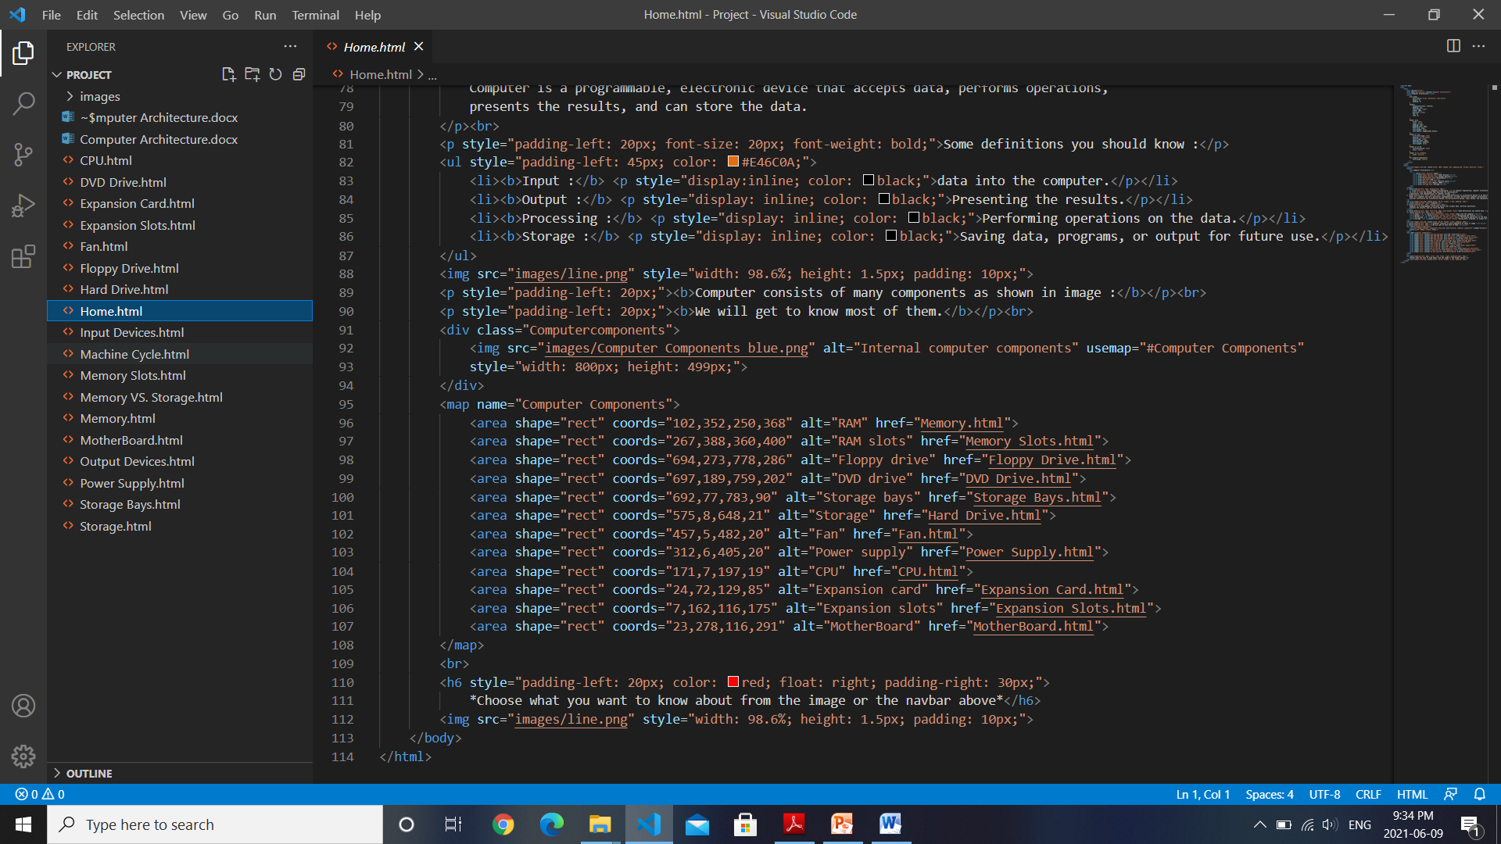

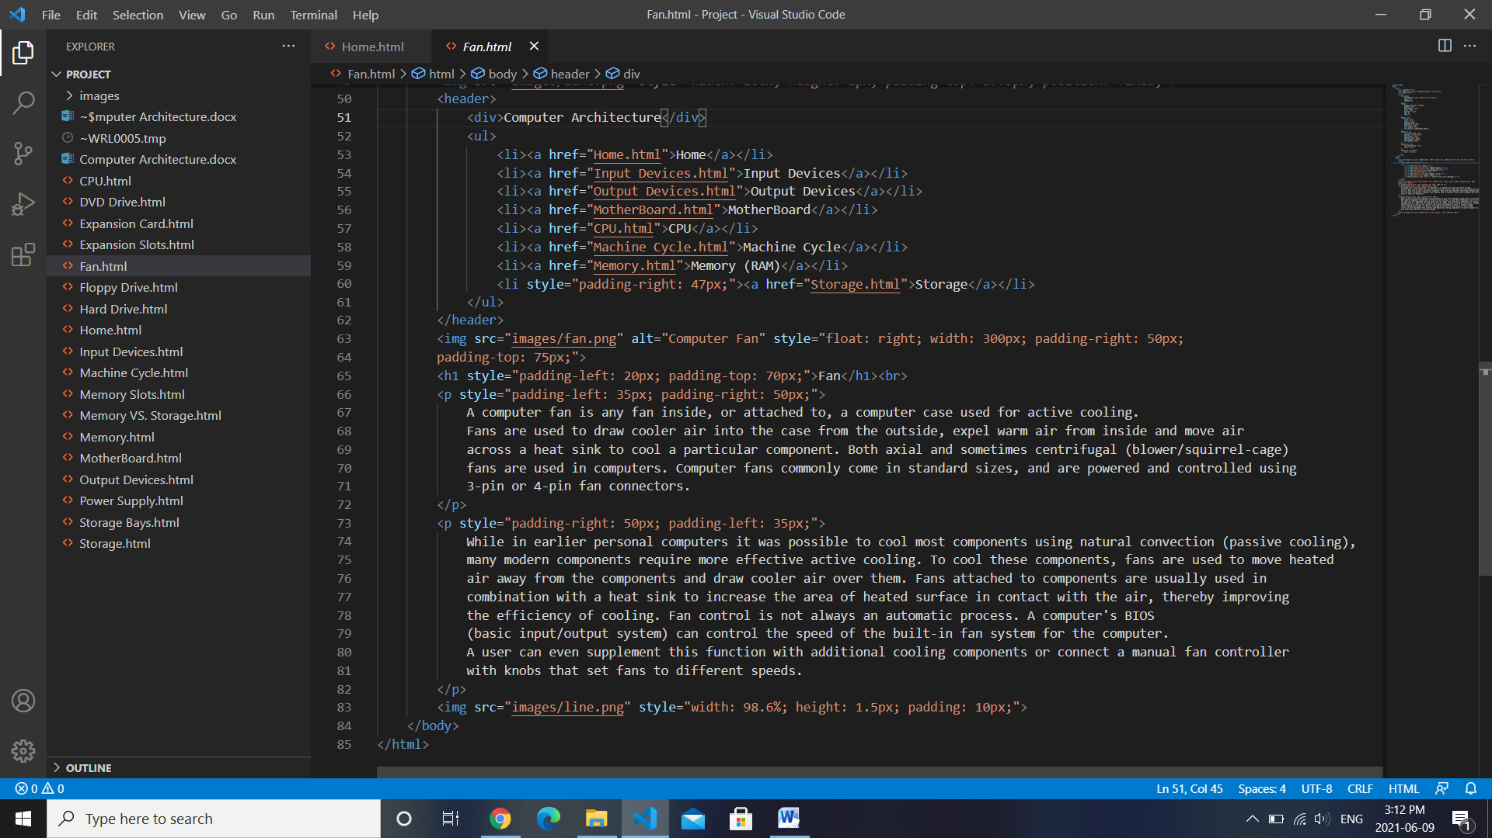

**Part of fan page code :**

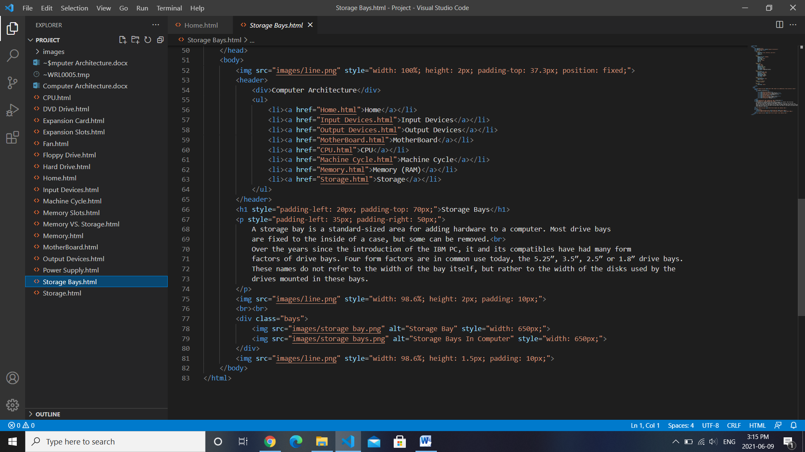**Part of storage bays code :**

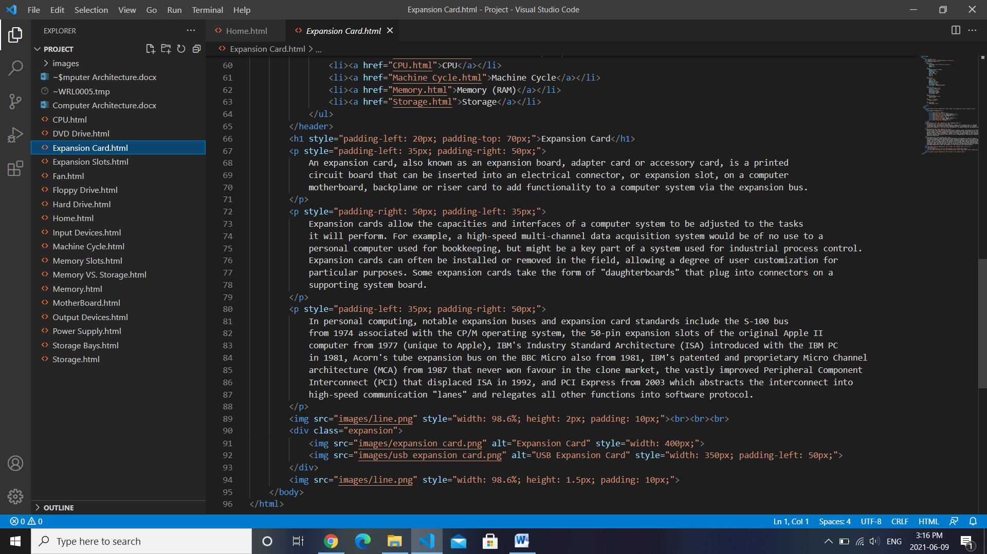**Part of expansion card page :**